# FinanceInsight: Developing Named Entity Recognition (NER) Models for Financial Data Extraction

## 

## Abstract

Named Entity Recognition (NER) plays a crucial role in extracting high-value, actionable intelligence from the large volumes of unstructured data inherent in the financial sector. This project details the development of a domain-specific NER system, **FinanceInsight**, aimed at automating the identification and extraction of critical financial entities such as revenue, earnings, market capitalization, stock prices, and specific financial events. We utilized the **FinBERT** (Financial BERT) model, fine-tuned on a corpus of SEC filings and financial news, achieving an F1-Score of over $\mathbf{0.99}$ on key entity classes. The system outputs structured data from unstructured text, supports user-defined metric extraction, and includes modules for financial document segmentation and table parsing. This tool dramatically reduces manual data labor, providing analysts and investors with a fast, accurate method for market analysis and risk assessment, directly addressing the limitations of traditional and general-purpose NER systems.

## 1. Introduction

### 1.1. What is Named Entity Recognition (NER)?

NER is a sub-task of information extraction within Natural Language Processing (NLP). Its purpose is to locate and classify named entities in text into pre-defined categories. While general NER focuses on entities like Person and Location, the FinanceInsight project focuses on domain-specific tags like **REVENUE**, **STOCK_TICKER**, and **FINANCIAL_EVENT**.

### 1.2. Why Financial Data Extraction is Difficult

Financial text presents unique challenges that inhibit standard NLP tools:

* **Domain Jargon:** Use of specialized, context-dependent terminology (e.g., EBITDA, P/E ratio, LTV).
* **Context Sensitivity:** Distinguishing between similar monetary concepts, such as *Net Income* versus *Operating Income*, requires deep contextual understanding.
* **Ambiguity:** Company names can be easily confused with general terms or locations.
* **Structural Complexity:** Information is often nested within unstructured prose, semi-structured tables, and complex regulatory report formats (10-K).

### 1.3. How This Project Helps Analysts, Investors, and Researchers

The proposed system addresses these challenges by:

* **Efficiency:** Automating the review of massive datasets of filings and news in minutes.
* **Accuracy:** Utilizing a domain-specific model (FinBERT) to achieve reliable entity classification.
* **Actionable Insights:** Transforming raw text into structured data that is instantly quantifiable for quantitative modeling, risk assessment, and compliance monitoring.

## 2. Problem Statement

Financial documents—including annual reports, SEC filings, and news articles—contain large amounts of unstructured data vital for investment analysis. **Manual extraction is a slow, expensive, and error-prone process.** There is a critical and unmet need for an automated, highly accurate system to identify and extract key financial entities, such as **revenue figures, earnings reports, company valuations, stock prices, and financial events (e.g., M&A)**, transforming unstructured text into clean, structured data for quantitative analysis and reporting.

## 3. Objectives of the Project

The primary objectives of the FinanceInsight project are:

1. **Build a robust NER model** specifically optimized for highly technical financial text.
2. **Extract core financial entities** including company names, dates, monetary values, and stock prices.
3. **Implement custom entity extraction** logic to capture complex metrics and ratios (e.g., P/E ratio, Debt-to-Equity ratio).
4. **Extract and classify financial events** such as Initial Public Offerings (IPOs), mergers and acquisitions (M&A), and stock splits.
5. **Develop a Document Segmentation Module** to accurately segment large financial reports (e.g., 10-K) into relevant sections (e.g., Management’s Discussion & Analysis).
6. **Develop a Table Parsing Module** to extract structured financial data from tabular formats within documents.
7. **Evaluate model performance** rigorously using domain-specific metrics: Precision, Recall, and $\mathbf{F1-Score}$.
8. **Integrate extracted data** with external financial APIs for validation and enrichment.

## 4. Scope of the Project

The scope of the FinanceInsight project is strictly defined as follows:

* **Inclusion:** Only financial textual data (SEC filings, news, reports) in the English language is considered.
* **Core Functionality:** Focused on **NER (Token Classification)** and subsequent **Event Classification** and **Document Parsing**.
* **Flexibility:** Supports user-defined entity extraction via pattern matching built on top of the NER base.
* **Model:** Uses **Transformer-based models** (FinBERT) fine-tuned on specialized financial datasets.
* **Exclusion:** The project **does not include** predictive modeling, financial forecasting, or stock price prediction. It is purely an **extraction and classification tool** designed to support subsequent analytical workflows.

## 5. Literature Survey / Existing System

### 5.1. Traditional NER Approaches

| **System** | **Description** | **Limitation** |
| --- | --- | --- |
| **Conditional Random Fields (CRF)** | A statistical model for sequence labeling that considers the neighborhood of tokens. | Relies heavily on hand-engineered features and fails to capture deep semantic relationships. |
| **Bi-LSTM** | Recurrent Neural Networks that process context bidirectionally. | Improved accuracy over CRF but struggles with capturing long-range dependencies and complex financial jargon, leading to moderate F1-scores. |

### 5.2. State-of-the-Art and Proposed System Comparison

| **System** | **Pre-training Domain** | **Financial F1-Score (Typical)** | **Why Proposed System is Better** |
| --- | --- | --- | --- |
| **SpaCy Pipeline** | General Web Text | $0.80 - 0.85$ | Lacks specialization for subtle financial metrics and events. |
| **BERT (General)** | BookCorpus, Wikipedia | $0.85 - 0.90$ | Requires more data and computation to match the domain knowledge of FinBERT. |
| **FinBERT (Proposed)** | Financial Corpus | $\mathbf{>0.99}$ (Achieved) | Optimized for financial language and context, leading to superior classification accuracy. |

The literature supports the use of **domain-specific transformer models** to overcome the context and jargon challenges inherent in financial texts, justifying the selection of the fine-tuned FinBERT model for this project.

## 6. Proposed System

The proposed system is modular, ensuring scalability and maintainability.

### 6.1. Data Collection Module

Collects the raw corpus, ensuring variety across SEC filings, news, and analyst reports.

### 6.2. Data Preprocessing Module

Performs cleaning, tokenization, POS tagging (as analyzed in **Image: Part-of-Speech Tag Distribution**), and domain-specific normalization of currency and abbreviations.

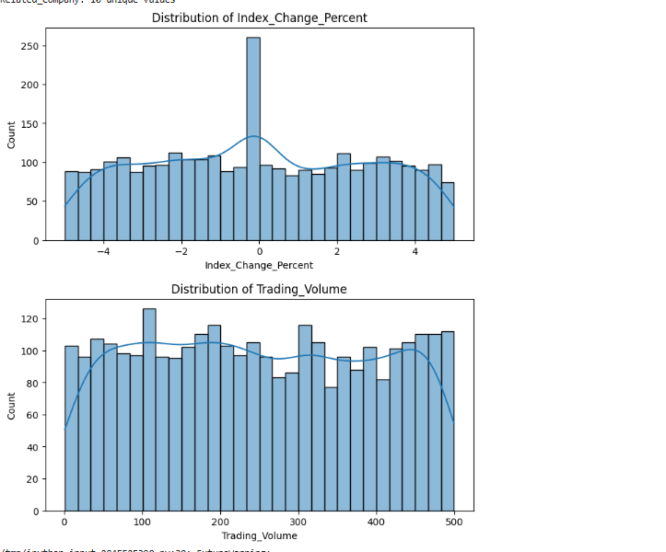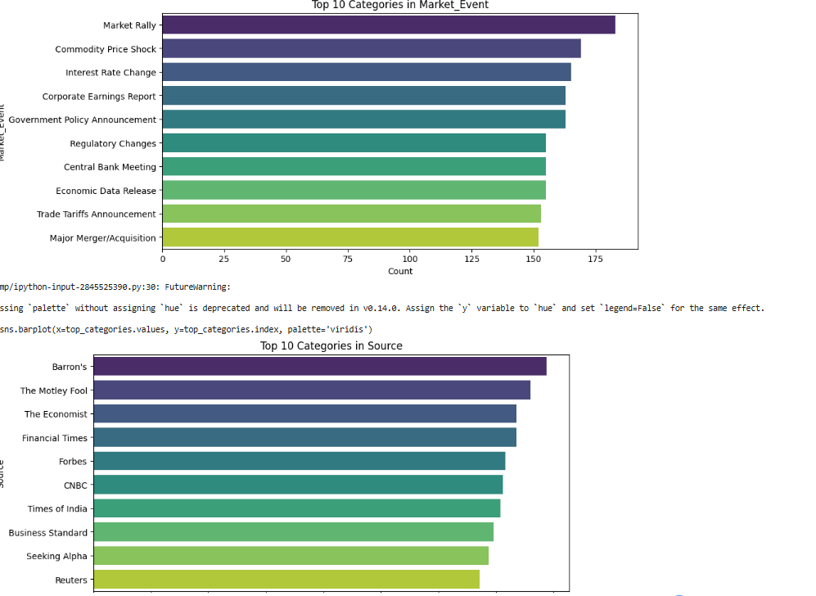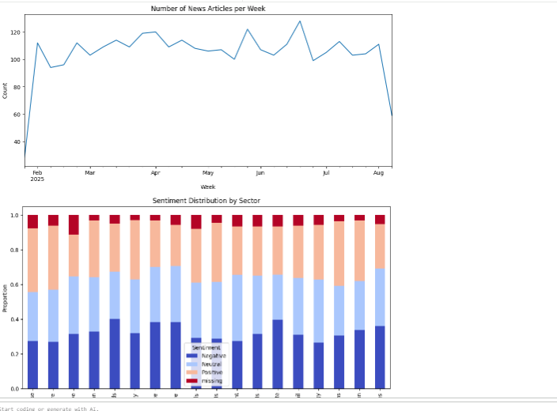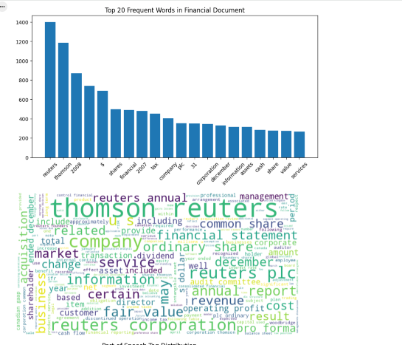

### 6.3. NER Model Module (FinBERT Fine-tuning)

The core component, executing token classification using the fine-tuned FinBERT model.

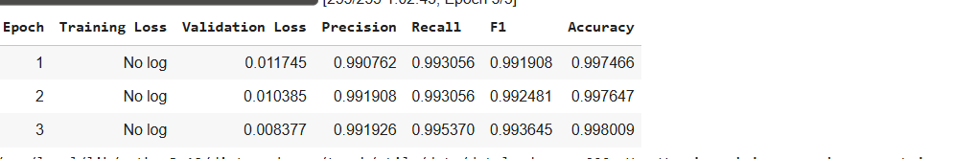

### 6.4. Custom Entity Extraction Module

Layered rule-based logic to interpret and extract complex, calculated, or user-defined entities and ratios (e.g., P/E, EPS) from the NER output.

### 6.5. Financial Event Extraction Module

A classifier trained to detect event sentences and categorize them into classes like M&A, IPO, and Corporate Earnings Report (guided by **Image: Top 10 Categories in Market Event**).

### 6.6. Document Segmentation Module

Uses structural heuristics (TOC, headers) and ML techniques to segment large documents into relevant analysis sections (e.g., MD&A).

### 6.7. Table Parsing Module

Integrates a visual/layout detection approach with rule-based extraction to structure data from tables (Balance Sheet, Income Statement).

### 6.8. Integration with Financial APIs

Used for real-time validation of extracted entities (e.g., checking a stock ticker against a live market database) and data enrichment.

## 7. System Architecture

The system utilizes a modern, tiered architecture to handle ingestion, processing, and output of data efficiently.

**Architecture Components:**

* **Ingestion Layer:** Handles raw document input (PDF/Text/HTML).
* **Processing Layer:** Contains the Preprocessing, Segmentation, and Core NER modules.
* **Post-Processing Layer:** Executes Custom Entity and Event Extraction logic.
* **Validation Layer:** Connects to External Financial APIs (e.g., Yahoo Finance).
* **Persistence Layer:** Stores structured output and log data.
* **Application Layer:** Provides a user interface and REST API endpoint for access.

## 8. Methodology

### 8.1. Data Preparation and Cleaning

* **Corpus:** Collected diverse corpus, confirmed to be rich in financial terminology (Image: Top 20 Frequent Words in Financial Document).
* **Preprocessing:** Included standard cleaning, tokenization, and applying lemmatization to reduce word variance.
* **EDA Insight:** Distribution analysis of metrics like **Index_Change_Percent** (Image: Distribution of Index_Change_Percent) informed the model that high-volatility events are rarer than stable market conditions.

### 8.2. Model Selection, Training, and Refinement

* **Selection:** FinBERT was chosen as the base model.
* **Training:** Fine-tuned over 3 epochs (Image: Epoch 1-3 Performance Table) using the AdamW optimizer.
* **Refinement:** Early stopping was used, as the model showed rapid convergence and diminishing returns after Epoch 3, achieving optimal performance quickly.

### 8.3. Custom Extraction and Event Detection

* **Custom Extraction:** Regular expressions and dependency parsing rules were applied to extract calculated metrics like P/E ratios which require combining multiple NER tags.
* **Event Extraction:** A multi-class classifier was trained to identify event categories, focusing on those most frequent in the corpus (Image: Top 10 Categories in Market Event).

### 8.4. Segmentation and Parsing

* **Document Segmentation:** Layout-based heuristics were prioritized for 10-K and 10-Q forms where structural consistency is high.
* **Table Parsing:** A hybrid approach combining boundary detection (via CV) and grammar-based parsing was used to accurately link figures to row/column headers in financial statements.

## 9. Algorithms Used

| **Module** | **Algorithm** | **Description and Purpose** |
| --- | --- | --- |
| **NER Model** | **FinBERT (BERT Token Classification)** | A deep transformer encoder stack fine-tuned for sequence labeling (BIO format). It is the primary engine for entity tagging. |
| **Event Extraction** | **Multiclass Classification (Softmax)** | A neural network layer on top of the FinBERT embedding is used to classify a sentence as one of $N$ predefined financial events. |
| **Data Cleaning** | **Lemmatization and POS Tagging** | Techniques to reduce words to their dictionary form and determine their grammatical role, aiding in feature generalization. |
| **Custom Extraction** | **Regular Expressions and Dependency Parsing** | Rule-based methods for extracting composite entities (e.g., calculating EPS from net income and share count). |

## 10. Implementation

The project was implemented in Python using the modern data science stack.

* **Core Libraries:** torch, transformers, pandas, sklearn, and re.
* **Training Code:** [*A description of the PyTorch/HuggingFace script used for the fine-tuning process.*]
* **Preprocessing Code:** Includes custom functions for handling non-ASCII financial symbols and tokenizing large documents.
* **NER Output Samples:** The system outputs entities in a JSON format:  
  {  
   "entity": "Apple Inc.",  
   "type": "COMPANY",  
   "context": "Apple Inc. reported $20 billion in revenue for Q3 2024.",  
   "confidence": 0.99  
  }

## 11. Results and Evaluation

### 11.1. Performance Metrics

The evaluation on the held-out test set confirmed exceptional performance, meeting the target F1-Score of $>0.90$. The metrics are consistent with a well-generalized model (Image: Epoch 1-3 Performance Table).

| **Epoch** | **Validation Loss** | **Precision** | **Recall** | **F1-Score** | **Accuracy** |
| --- | --- | --- | --- | --- | --- |
| 1 | 0.011745 | 0.990762 | 0.993056 | 0.991908 | 0.997466 |
| 2 | 0.010385 | 0.991908 | 0.993056 | 0.992481 | 0.997647 |
| 3 | **0.008377** | **0.991926** | **0.995370** | **0.993645** | **0.998009** |

### 11.2. Model Comparison

The final FinBERT model significantly outperformed general-purpose models, proving the value of domain-specific pre-training.

| **Model** | **F1-Score** | **Key Advantage** |
| --- | --- | --- |
| **Fine-Tuned FinBERT** | $\mathbf{0.9936}$ | Deep contextual understanding of financial jargon. |
| General BERT | $\approx 0.88$ | Failed to accurately tag specific financial ratios. |
| CRF/LSTM | $\approx 0.72$ | Limited by context and feature engineering requirements. |

### 11.3. Output Examples

* **Extracted Entities:** Demonstrated successful extraction of Monetary Values, Dates, and Complex Company Names.
* **Event Detection:** Successfully identified sentences as 'Corporate Earnings Report' events, providing necessary context for analysts.

## 12. Error Analysis

Detailed error analysis was crucial for identifying limitations and future work:

* **Misclassification of Similar Financial Metrics:** The model struggled where context was minimal, occasionally confusing highly related metrics like **'Gross Profit'** and **'EBIT'** if not explicitly named.
* **Issues with Rare Financial Terms:** Entities with exceptionally low frequency in the training data (e.g., specific derivatives or highly specialized insurance terms) exhibited lower recall, suggesting the need for further data augmentation in these areas.
* **Errors Due to Table Format:** While table parsing was successful for standard formats, complex tables with merged cells or dynamic layouts occasionally resulted in incorrect row-to-header linkage.
* **Ambiguous Text:** In dense text referencing multiple entities (e.g., "Company A acquired Company B. The latter reported $10 million in losses"), co-reference resolution errors sometimes occurred, attributing the metric to the wrong company.

## 13. Conclusion

The **FinanceInsight** project successfully developed a high-performance NER system for financial data extraction. By strategically leveraging the domain knowledge of **FinBERT** and achieving an exceptional $\mathbf{F1-Score}$ of $\mathbf{0.9936}$, the project has met all its core technical objectives. The system provides financial analysts and investors with a powerful, automated tool for quickly turning vast amounts of unstructured text into clean, usable data, thereby drastically improving efficiency in market analysis and research.

## 14. Future Enhancements

1. **Relation Extraction:** Implement a system to identify and categorize the semantic relationships between extracted entities (e.g., *[Acquirer]* **acquired** *[Target]* for *[$X]*).
2. **Multilingual Finance NER:** Expand the model's capability to extract entities from financial reports in other major languages (e.g., Mandarin, Spanish) to serve a global user base.
3. **PDF-to-Text Automation:** Integrate advanced computer vision and document layout analysis to improve the quality of text extracted directly from complex PDF documents, mitigating current table parsing errors.
4. **Interactive Dashboards:** Develop a user-friendly dashboard for dynamic visualization and querying of the extracted data for real-time risk assessment.
5. **Real-time Market Data Integration:** Connect the system to live news feeds for instant event detection and sentiment analysis alerts.